Title: Violence Reduction and Access to Higher Education: Post‑Conflict Evidence from Colombia
Research question: How does the reduction of violence following the Colombian peace agreement affect access to higher education?
Abstract: This study aims to examine how Colombia’s violence reduction affects higher education access. In December 2014, the national government and the FARC guerrillas agreed to a ceasefire during the peace agreement process, which ended with the peace agreement signature in November 2016. The ceasefire led to a decrease in violence nationwide, particularly in municipalities where the guerrilla group had a stronger presence. Recent evidence has shown that the reduction in violence increases school retention and improves academic performance for primary and secondary students in these areas. However, there is a lack of information regarding the effects on higher education; therefore, this analysis focuses on filling this gap using a difference in differences method.
Gap: There is no evidence about the relationship between armed conflict and violence and higher education access.
Relevance: The Colombian case is of particular interest, given the long duration of the
armed conflict, which has been widely studied for its negative effects on multiple social dimensions. However, the ceasefire agreement and the subsequent decline in violence offer a unique opportunity to examine the recovery process of a society emerging from decades of conflict. This is relevant not only for supporting domestic public policies aimed at strengthening the factors that improve social conditions, but also for understanding the mechanisms that contribute to social reconstruction.

Context: Armed conflict in Colombia

According to the Commission for the Clarification of Truth, Coexistence, and Non-Repetition between 1995 and 2018, 450,664 people lost their lives, 121,768 were forcibly disappeared, 50,770 were kidnapped, 16,238 children were recruited, and 752,9642 suffered forced displacement. The FARC played a significant role in perpetrating these violent acts, which is why the peace agreement reached represented an important milestone in improving security conditions in the national territory (Prem, Vargas, and Namen 2023).
Data:
Higher education
- Students who present the standardized national exam Saber 11. Anonymized information is publicly available through the ICFES web portal.
  - This population is the potential demand for higher education.
  - Period: 2010 - 2024
- Access to higher education programs (technical, technological, and professional). The match between higher education enrolment and anonymized Saber 11 information is available through the ICFES web portal.
Using this information, I can determine the number of students who progressed to higher education and the timing of their entry. The key outcome variable is immediate transition to higher education, measured as the proportion of students who enrol in higher education in the year immediately after completing their examinations.
El ponderador natural es el número de presentadores de Saber 11 del municipio en cada año. Es lo que estabiliza la varianza de una media de proporciones. Utilizar el promedio pre-cese del número de presentadores, no el valor año a año, para que el peso de cada municipio no cambie con el tiempo por razones que podrían ser endógenas al propio conflicto.

In addition, I can run a heterogeneous effect analysis for men and women using the same measure, but in this case by sex.
To determine the municipality of origin of each student, I will use the recorded municipality of residence at the time they sat their examinations.
Violence
- The Historical Memory Centre in Colombia has all the data related to human rights violations committed within the armed conflict context. It is at the municipal level, from 1996 to 2024. It records the number of events and victims associated with targeted killings, terrorist attacks, kidnappings, sexual violence, massacres, enforced disappearances, antipersonnel mines, recruitment of children and adolescents, and other forms of violence.
Variables: the alleged perpetrator, the date and location of the event, the type of violent act, the number of people affected, and other relevant variables.
Using this information, I will construct a measure of violence.
- Violence measure:
To define the municipalities with FARC presence, I will use information from 2011 to 2014 to identify those municipalities based on the number of events that took place there. This allows me to have a clean identification mark, unaffected by the peace agreement process and the ceasefire.
‘There are 13 municipalities between 2015-2016 that had their first FARC related event, those are not considered in the treatment group. Dicho todo esto, tu instinto empírico no se desperdicia. La actividad FARC residual en 2015–2016 es material valioso, solo que para otro lugar del análisis, no para definir el tratamiento. Tres usos legítimos: como variable de resultado intermedia o chequeo de primera etapa (mostrar que la violencia efectivamente cayó más en los expuestos, y dónde no cayó del todo); como control de robustez (excluir o marcar esos municipios donde el cese fue incompleto y ver si tu efecto se mantiene); o como una nota sustantiva sobre la heterogeneidad del cumplimiento del cese. Lo que no debe hacer es entrar en la regla que decide quién está tratado.’
To construct the pre-ceasefire FARC exposure measure, we aggregate events across four violence categories over the 2011–2014 period: war actions, terrorist attacks, damage to civilian infrastructure, selective killings, kidnappings and antipersonnel mines. These categories capture the tactical repertoire most directly associated with FARC's military strategy and territorial control (Restrepo, Spagat, and Vargas 2004; Richani 2002). War actions represent the largest share of identified FARC events (79% of attributed cases in 2011–2014) and exhibit the sharpest differential reduction after the ceasefire — 79% in exposed municipalities versus 53% in non-exposed ones (Prem, Vargas, and Namen 2023, Table 1). Antipersonnel mines are included on two grounds: they constitute a signature FARC tactic whose use dropped by 72% in exposed municipalities after the ceasefire, and there is independent evidence that landmine prevalence has a causal negative effect on schooling and human capital investment (Lekfuangfu 2022; Perilla, Prem, Purroy, and Vargas 2024).
I exclude four categories from the main basket. Forced disappearances and sexual violence are dominated by non-FARC perpetrators — particularly paramilitary groups — and exhibit severe underreporting in the CNMH data (CNMH 2013). Massacres are similarly excluded: the AUC was responsible for approximately 80% of all massacres in Colombia between 1994 and 2002 (CNMH 2013; Restrepo, Spagat, and Vargas 2006), and the post-ceasefire differential in massacre rates between exposed and non-exposed municipalities is statistically indistinguishable from zero (p = 0.95; Prem, Vargas, and Namen 2023, Table 1). Property damage is excluded due to an insufficient number of events (N = 13 total in 2011–2014).
- Treatment variable:
Inputs to define the treatment measure:
Distribution of FARC violent events per capita across municipalities during the pre-period 2011-2014.

To measure the effect of the violence reduction caused by the ceasefire, I am proposing three different measures of treatment.
- FARC presence: equal to 1 if, during 2011-2014, there was any violent event per 10.000 inhabitants in the municipality caused by the FARC group. 0 otherwise.
Pros: simple and easy to interpret.
Cons: trata igual a un municipio con 1 ataque y a uno con 50 (pierde la relación dosis-respuesta); es muy sensible a errores de atribución, porque un solo evento mal asignado cambia el estatus de un municipio definido por conteos bajos; el grupo expuesto es heterogéneo, así que si el efecto se concentra en los muy afectados, lo binario diluye $β$hacia cero; y el control (971) puede incluir municipios muy distintos (urbanos, sin conflicto alguno), lo que tensiona el supuesto de tendencias paralelas.
Question: ¿mejoró el tránsito a educación superior en los municipios que tuvieron presencia FARC pre-cese, frente a los que no, tras el cese? Estima un efecto promedio sobre todo el grupo expuesto, sin distinguir intensidad.
- FARC high and low exposure: number of violent events per 10.000 inhabitants greater than the median of the distribution of events in municipalities with FARC presence are highly exposed.
Estimar por separado el efecto de baja y de alta intensidad contra el mismo grupo no expuesto, con unexposed como referencia.
In the DiD it looks like this. Instead of a single treatment dummy interacted with the ceasefire, you interact the ceasefire with the intensity factor, taking unexposed as the reference level. That produces two coefficients:
- one for low × cease: the change in the outcome after the ceasefire for low-intensity municipalities, relative to the unexposed.
- one for high × cease: the same, for high-intensity municipalities, relative to the unexposed.
FARC presence location
It matches the known geography of FARC presence — concentrated in the south and southwest (Cauca, Nariño, Putumayo, Caquetá, Meta) and in Antioquia, Norte de Santander, and Arauca, with the Caribbean coast and central Andes largely as control.
For the thesis, you may want to cite it as DANE's Marco Geoestadístico Nacional 2021

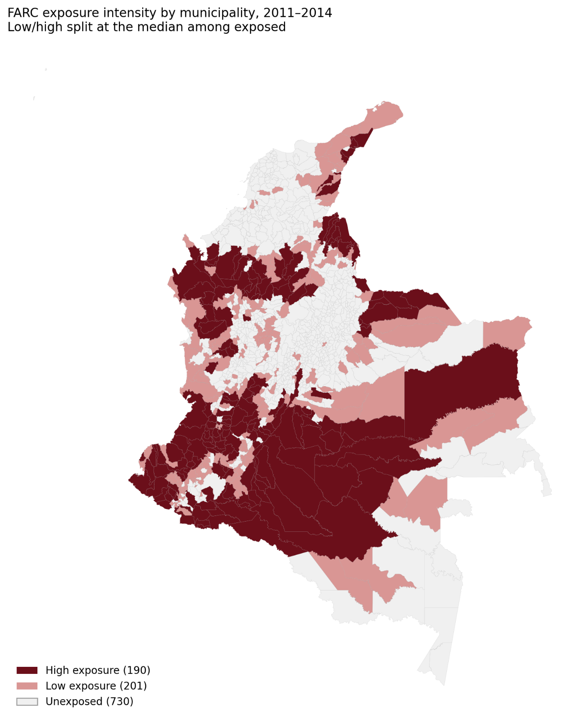
The high-exposure municipalities cluster in the historic FARC strongholds — Caquetá, Meta, Putumayo and southern Cauca/Nariño in the south, plus the Urabá–Antioquia and Catatumbo/Arauca corridors — while low-exposure units tend to ring those cores or sit along their edges. That gradient from core to periphery is precisely what makes the three-arm dose-response credible: low-exposure places are mostly the margins of conflict zones, not a random scatter.
Possible spillover effects:
El supuesto que el spillover rompe es SUTVA: que el resultado de un municipio control no dependa del tratamiento de sus vecinos. Tu mapa muestra justo la configuración donde ese supuesto es frágil. Los municipios de baja exposición (rojo claro) forman anillos alrededor de los núcleos de alta exposición (rojo oscuro), y muchos controles grises son contiguos a municipios tratados. Cuando tratamiento y control comparten frontera, el cese al fuego en un municipio expuesto puede "derramar" sobre sus vecinos por varios canales concretos:
Movilidad estudiantil: un joven que vive en un municipio control pero cuyo municipio vecino expuesto se pacifica puede ahora desplazarse a estudiar allá, o al revés. Como tu resultado es acceso a educación superior y la oferta suele estar en cabeceras subregionales, este canal es directo.
Mercados y migración: el fin del conflicto en un núcleo reactiva economía, vías y movimiento de población que cruzan fronteras municipales. Desplazados que retornan, familias que se mueven.
Reorganización armada: tu propio dato de 2015–2016 mostró actividad FARC residual; los grupos no respetan límites DIVIPOLA, y el vacío de poder tras el cese se redistribuye espacialmente.
Dirección del posible sesgo
Esto es lo importante para interpretar. Si el cese mejora el acceso en los expuestos y también derrama positivamente sobre los controles vecinos, entonces tu grupo de control está parcialmente "tratado". Eso contamina el contrafactual y, como la comparación es tratado-vs-control, el spillover positivo sobre controles atenúa tu estimación: el verdadero efecto es mayor que el que mides. Si el derrame fuera negativo (p. ej. desplazamiento de violencia hacia zonas vecinas), el sesgo iría en sentido contrario. Dado el mecanismo más plausible aquí, lo más probable es atenuación — tu β sería una cota inferior.

- Continuous measurement:
Municipality information
I will complete the previous information with economic variables, including tax income, expenditure, transfers from the national government, and hectares cultivated with coca.
Methodology: Causal inference approach using a difference in differences method.
The goal is to estimate the causal effect of the December 2014 ceasefire on higher education access. The core challenge is that the counterfactual is never observed: I cannot know what would have happened in FARC-exposed municipalities had the ceasefire not taken place.
DiD resolves this elegantly. Rather than comparing treated and control municipalities at a single point in time — which would confound the treatment effect with pre-existing differences between groups — it compares changes over time across groups.
Formally, the DiD estimator is:
$$AccessHE_{mdt}=β\left(Cease_{t}*FARC_{m}\right)+α_{m}+γ_{dt}+e_{mdt}$$
Where $FARC_{m}$ identifies municipalities' exposure to FARC violence, and $Cease_{t}$ is equal to 1 from 2015 when the ceasefire began. $β$ is the coefficient of interest showing the effect of the ceasefire on higher education access.
The difference between the change in treated municipalities, those with FARC exposure, and the change in control municipalities. The change means the difference between post-ceasefire and pre-ceasefire.
- Treated: municipalities with pre-ceasefire FARC presence
- Control: municipalities without FARC presence
- Pre-period: 2011–2014
- Post-period: 2015–2023
- Outcome: share of Saber 11 test-takers in year t who enrolled in higher education in year t+1
The intuition is straightforward. The control group tells you how the outcome would have evolved in treated municipalities in the absence of treatment — that is, your constructed counterfactual.
Intuition: Lo central es que ninguno de los dos papers compara directamente "violencia vs. no violencia". Comparan la evolución de un resultado, antes vs. después del cese, entre municipios expuestos y no expuestos a las FARC. La lógica es:
- El cese al fuego es un shock que "golpea" con fuerza a los municipios expuestos, porque son los únicos donde efectivamente había violencia de las FARC que ahora cae.
- Los municipios no expuestos (o poco expuestos) funcionan como contrafactuales: lugares donde el cese cambia poco, porque allí casi no había violencia de las FARC que reducir.
- La pregunta de DiD es entonces: ¿mejoró (o empeoró) el resultado de forma diferencial en los lugares que más se beneficiaron del cese, en relación con los que no?
¿el cese al fuego con las FARC mejoró la tasa de tránsito a educación superior en los municipios más afectados por las FARC, frente a los menos afectados?
Main assumptions
DiD rests on a single identifying assumption that cannot be tested directly but can be evaluated empirically: in the absence of the ceasefire, treated and control municipalities would have followed parallel trajectories in higher education transitions.
This does not require that the two groups have equal outcome levels. FARC-exposed municipalities may have systematically lower transition rates than controls — and they likely do. What is required is that the trend would have been the same.
The event study should take 2013 as the year of reference due to the outcome occurring in t+1, and for the 2014 cohort, the outcome happens in 2015, which is after the ceasefire.
Event studies
The event study answers both by estimating a separate treated-vs-control difference for every year, all measured relative to a base year (2014 in your case).
for each year, estimate how far apart the exposed and unexposed groups are, and express it as a deviation from where they stood in 2013. The year 2013 is pinned to zero by construction — it's the reference everything else is measured against. So each coefficient is "the exposed-vs-unexposed gap in year t, minus that same gap in 2013." Plotting those coefficients over time is the event study.
That construction gives you the two readings the plot is built around. The pre-treatment coefficients (2011–2013) are the test: if the parallel-trends assumption holds, the gap between groups shouldn't have been changing before the ceasefire, so those coefficients should sit at zero. Points hovering around zero with intervals covering it — like in your figure — mean you can't reject that the trends were parallel. If instead they trended up or down before 2014, that's evidence the groups were already diverging for other reasons, and your DiD would be confounded. This is why the event study is considered a stronger validation than just eyeballing the two raw trend lines: it nets out the fixed effects and tests the pre-period formally.
Relevant previous evidence, supporting the possible mechanism if I found an effect.
- The human capital peace dividend (2023). Mounu Prem, Juan F Vargas, Olga Namen.
Findings: ceasefire declared by FARC’s insurgency during peace negotiations with the Colombian government caused a differential improvement on several educational outcomes in the areas affected by FARC violence before the ceasefire. – school dropout + high school graduation + academic performance

- Educational outcomes in times of conflict and post-conflict. Montano Bardales and Palacios (2025), the peace agreement had a positive effect on gross enrolment, dropout rates, and academic performance, but gaps between the most affected municipalities and the least affected ones have widened.

